MA40198 Coursework

**Introduction and Aim**

This report explores the capabilities of a new pharmaceutical treatment; primarily finding the maximum safe dosage of the treatment. Only 40 data points from a phase 1 clinical trial were available with three measured observations for one: the dose received, the measured response of the dose and the presence of a certain biomarker. The second aim of this report is to decide if the the biomarker raises the tolerance of the patient in response to the treatment. The hypothesis test for this analysis is as follows: the null hypothesis is that the biomarker does not affect the tolerance of the patient to the treatment against the alternative hypothesis where the biomarker does affect the tolerance to the treatment. From our initial analysis of the data (shown below), we expect to accept the alternative hypothesis and be able to fit a model to the data as there appears to be a relationship between the dose and response that is distinct for those patients with and without the biomarker.

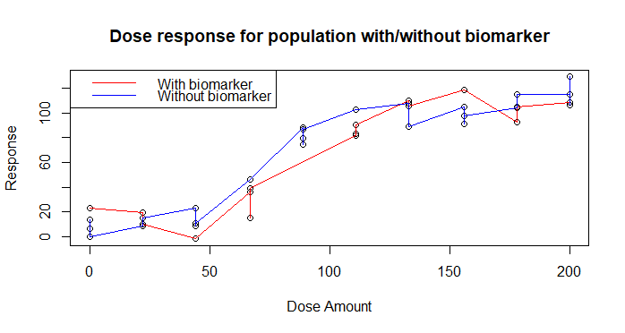

**The model considered**

To model the response of the dose, we use the four parameter Emax model:



The terms are defined as follows: ri is the measure response for the dose for the ith patient; di is the dose given to the ith patient; xi indicates whether the ith patient has the biomarker (1 for present and 0 otherwise); E0 is the response when the drug is not given; λ is the slope factor defined as sensitivity measured to the dose of the treatment; ED50 is the dose of the treatment that gives half the maximum response, Emax; β measures the change in ED50 with the biomarker is present in the patient; and εi is the error term for patient i given by εi ~N(0,σ2).

Furthermore, ED30, which represents the maximum safe dose, is defined as:



The Emax model is suitable for analysing this trial because: it adapts to the response without the drug present, E0; it accounts for the presence of the biomarker, denoted by xi, so it is possible to determine how and if the biomarker affects the patients’ tolerance to the treatment, a key aim of the study; and the slope factor coefficient, λ, accounts for the sensitivity to the dose of the treatment and is helpful to understand the relative differences between the levels of dosage given.

**Metropolis-Hastings: Results**

To calculate the parameter values in the Emax model we used the Metropolis-Hastings algorithm. Our implementation used the function ll which returns the log likelihood of the model. It ensures that the only accepted proposals contain real numbers by returning -infinity if ED50 + β ≤ 0. We also used the function pri which returns the logged prior of our parameters. It uses the following prior distributions for E0, Emax, ED50, λ, σ2 and β respectively:Norm(0,10), Norm(100,10), Beta(2.5,5), Unif(0.5,3) and Norm(0,3) truncated with a lower bound of 0. This function also ensures that accepted proposals contain real numbers by returning -infinity if ED50 + β ≤ 0.

We ran two versions of the Metropolis-Hastings algorithm. Firstly, we used a random walk proposal with starting values of 4.63, 115, 75, 3, 3.66 and 11.8 and standard deviations of 1.9, 2.4, 1.5, 0.04, 0.04 and 1.4 for E0, Emax, ED50, λ, σ2 and β respectively. We then tested for correlation between the posterior distribution of each parameter in the model by calculating the sample correlation between each parameter and performing the Pearson’s product-moment correlation test. The results (shown below) showed significant negative correlations between E0 and Emax and between ED50 and β whilst E0 and ED50 were significantly negatively correlated. Next the Metropolis-Hastings algorithm was re-ran using the covariance matrix for the posterior distributions, the same starting values and a standard deviation of 0.9.

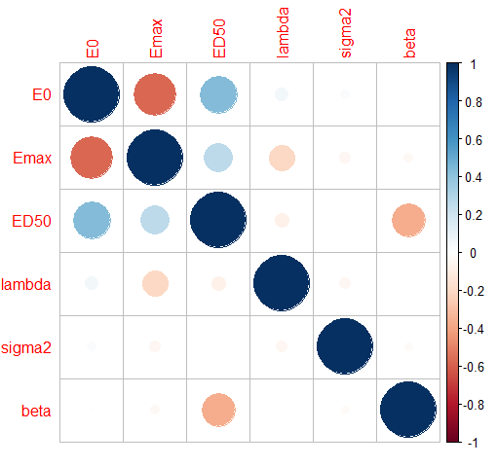

After running the Metropolis-Hastings both times we checked for convergence by subsampling independent observations of each parameter in both proposals. This independent subsampling is done by calculating the autocorrelation length, $k_{i}$, of the $i$-th parameter and keeping the $k_{i}$-th element of the vector of observed values for each parameter. Afterwards, we divided our independent samples into two populations and performed the two-sample Kolmogorov-Smirnov to test if the populations follow the same distribution. The tests showed that the samples of the posterior distribution obtained from both runs of the Metropolis-Hastings sampler converged as all parameters yielded a p-value greater than 5%. As both proposals were feasible we used the Deviance Information Criterion (DIC) to decide which had the best fit. The first sampler gave DIC of 127.9149 whilst the second gave a DIC of 127.7179. Although the difference is small, including the correlations from the posterior distribution provides a better fit and this is the model we shall use. The findings from both the Kolmogorov-Smirnoff tests and DIC match our expectations from running the algorithms as the trace plots showed good mixing and the cumulative average plots showed convergence. The plots shown below are only for the run including the correlations as the plots were alike for both runs as the similar DIC shows.

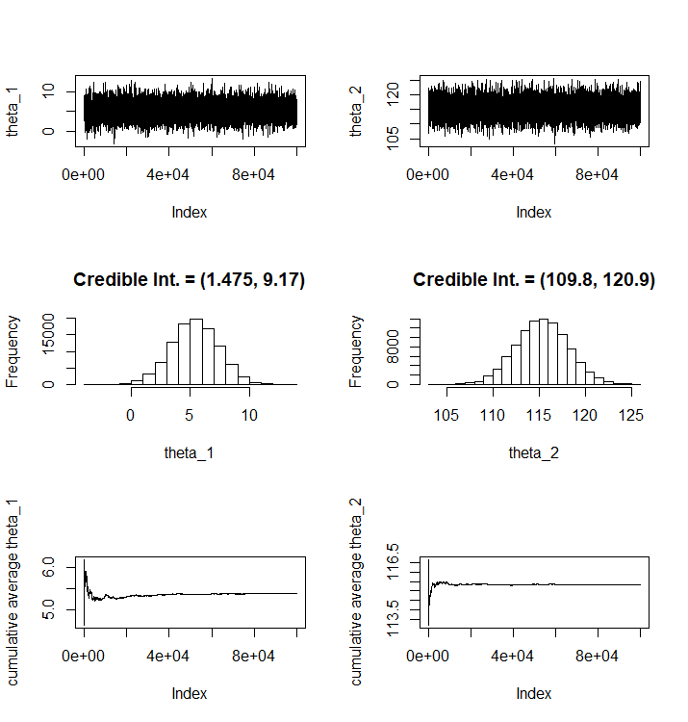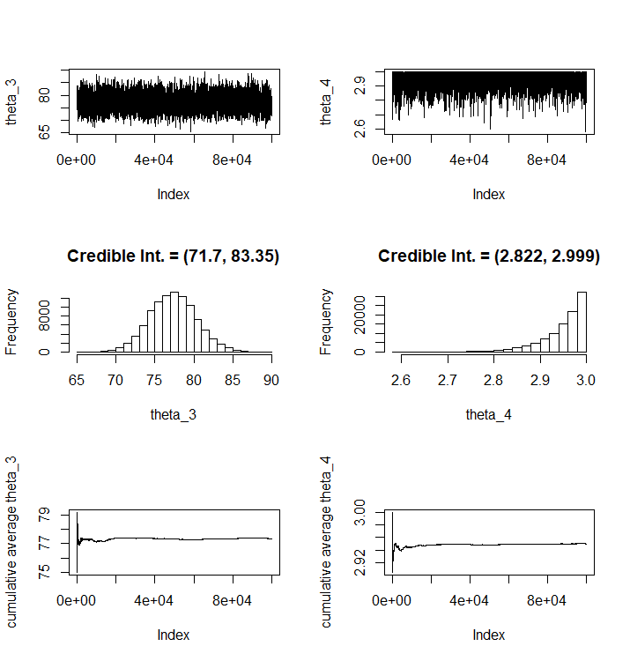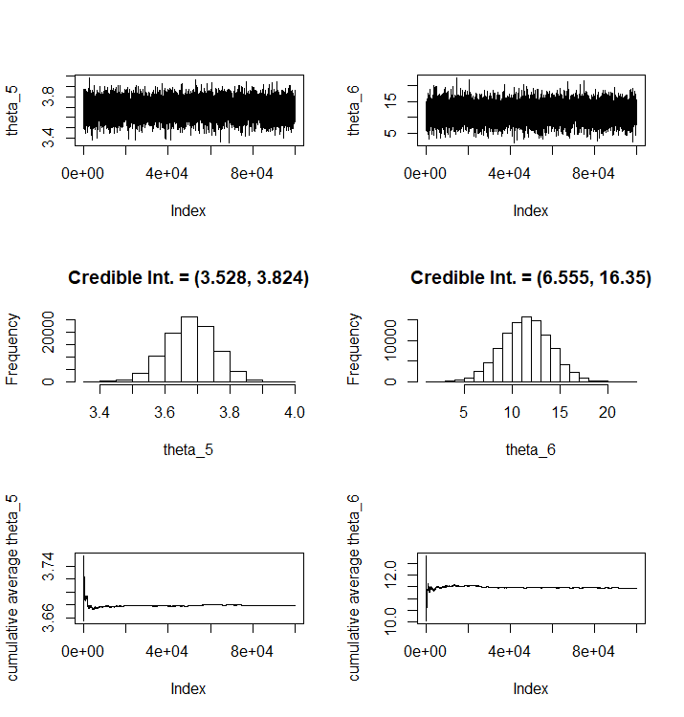



**Conclusion**

Having considered the tolerance levels of the individuals in the phase one of the trial with and without the biomarker, it would be advisable for the clinicians to set the maximal safe dose to ED30 for future trials.

<http://www.math.chalmers.se/~rootzen/finrisk/reportwriting0315.pdf> : for how to write a report

<https://www.wikihow.com/Write-a-Statistical-Report>

<http://file.zums.ac.ir/ebook/75-Dose%20Finding%20in%20Drug%20Development%20(Statistics%20for%20Biology%20and%20Health)-Naitee%20Ting-0387290745-Sp.pdf>